Grocery Inventory Data
1.Project Overview Objective
The Grocery Inventory project focuses on managing and analyzing stock, sales, suppliers, and product performance. It helps track inventory levels, monitor demand, and support data-driven decisions to improve overall store efficiency.
Objectives
- Optimize inventory levels to avoid overstock and stockouts
- Analyze sales and profit trends across categories and products
- Improve reorder planning based on stock and demand
- Evaluate supplier performance for better sourcing decisions
- Enable better decision-making using dashboards and insights
2. Data Sources
- Primary dataset: Grocery Inventory dataset (Excel/CSV format)
- Imported into Power BI for analysis
- Contains product, supplier, stock, and sales details

3. Problem Statement
Retail businesses often face challenges such as:
- Stock shortages or overstocking
- Expired product losses
- Poor demand forecasting
- Inefficient supplier management
4. Attribute (Column / Features) Details
Attribute Name | Data Type | Description
Product ID | Text | Unique product identifier
Product Name | Text | Name of product
Category | Text | Product category
Supplier ID | Text | Supplier unique ID
Supplier Name | Text | Supplier name
Warehouse Location | Text | Storage location
Status | Text | Product availability status
Stock Quantity | Whole Number | Available stock
Reorder Level | Whole Number | Minimum stock threshold
Reorder Quantity | Whole Number | Quantity to reorder
Unit Price | Decimal | Price per unit
Sales Volume | Whole Number | Units sold
Inventory Turnover Rate | Decimal | Inventory movement rate
Last Order Date | Date | Last order date
Expiration Date | Date | Product expiry date
Percentage | Decimal | Performance metric
5. Tools & Technologies
- Power BI → Data visualization & dashboard
- Excel → Data storage & initial cleaning
- Power Query → Data transformation
- DAX → Calculations and measures

6. Data Pre-Processing (Excel / Power Query)
Steps performed:
- Removed duplicate records
- Handled missing values
- Standardized column names and formats
- Converted data types (date, number, text)
- Created calculated columns if needed
- Filtered irrelevant or incorrect data

7. Data Modelling and DAX (Power BI)

Data Modelling:
- Used Star Schema (simple model)
- Fact Table: Inventory data
- Dimension Tables: Product, Supplier, Category
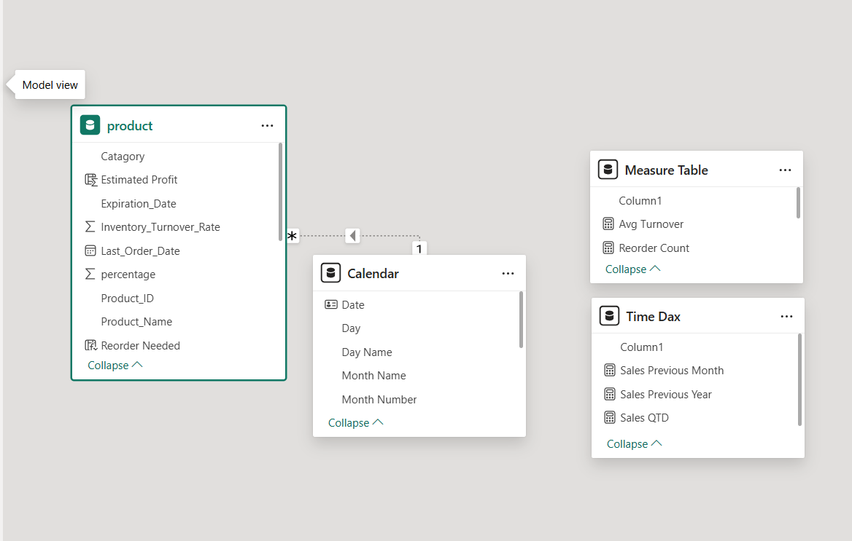

8. Analysis and Visualizations (Power BI)

Dashboard Features:
- Stock Quantity by Product (Clustered Bar Chart)
- Count of product Id by Status (Pie Chart )
- Sales Volume by Category ( Clustered Column Chart)
- Profit Wise Category (Tree Map)
- Product Supplier Wise Reorder Level Status (Table View)
- Sales by Supplier (Stacked Bar Chart)
- Stock Quantity Wise Reorder (Donut Chart)
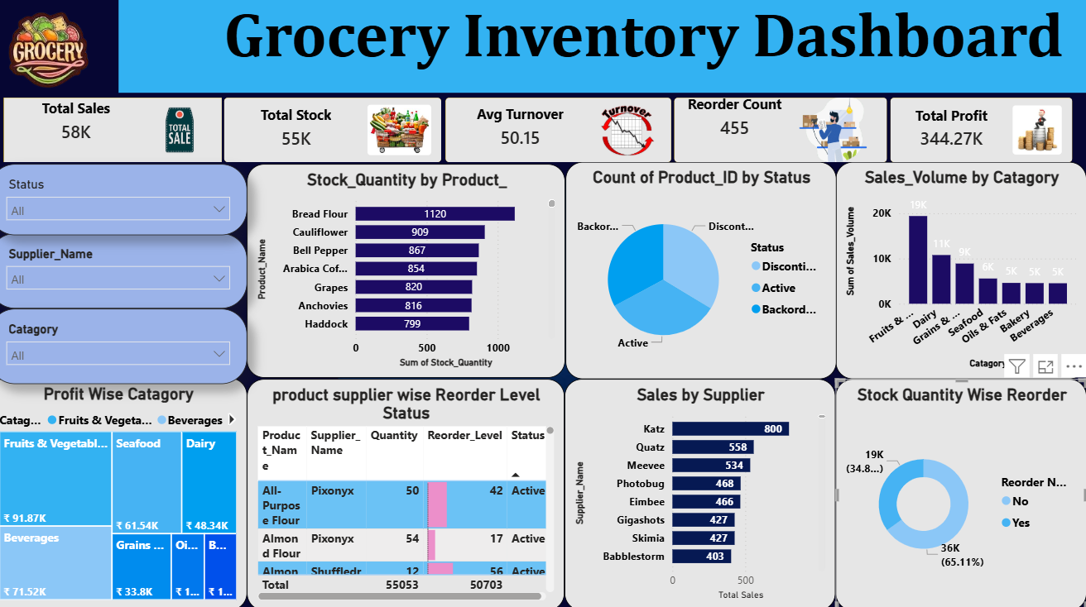
- Stock Quantity by Pruduct (Clustered Bar Chart)
Inventory is well-balanced, with high stock in items like Bread Flour (1120), Cauliflower (909), and Arabica Coffee (854). However, essential items such as Milk (160), All-Purpose Flour (159), and White Rice (172) have low stock levels. This indicates a need to restock low-value items while managing overstock in high-value products.

b) Count of product Id by Status (Pie Chart )

The dataset analyzes the number of products based on their status: Active, Discontinued, and Backordered. A total of 990 products are distributed almost equally across these three categories.
Summary
- Discontinued: 333
- Active: 332
- Backordered: 325
- All three statuses are almost equally distributed
Insights
- The inventory status is evenly balanced, showing no single dominant category
- Slightly higher discontinued items (333) may indicate outdated or unsold products
- Backordered items (325) are also high → potential supply or demand issues
c) Sales Volume by Category ( Clustered Column Chart)
This dataset represents the total sales volume of products across different categories in the grocery inventory. It helps in understanding which categories contribute the most to overall sales and which ones perform poorly.
Summary
- Highest sales: Fruits & Vegetables (19,397)
- Followed by Dairy (10,772) and Grains & Pulses (8,886)
- Lowest sales: Beverages (4,533), Bakery (4,564), Oils & Fats (4,606)
Insights
- Fruits & Vegetables dominate sales, showing highest demand and fast movement
- Dairy and Grains have strong, consistent sales → essential daily products
- Beverages, Bakery, and Oils have lower sales → may need promotions or demand analysis

d) Profit Wise Category (Tree Map)
Summary

- Highest profit: Fruits & Vegetables (₹91,874.49)
- Next: Beverages (₹71,517.55) and Seafood (₹61,539.10)
- Lowest profit: Bakery (₹18,354.30) and Oils & Fats (₹18,841.90)
Insights
- Fruits & Vegetables generate the most profit, making them the key revenue driver
- Beverages show strong profitability despite lower sales → high margins
- Bakery and Oils & Fats have low profit, indicating low margins or pricing issues

e) Product Supplier Wise Reorder Level Status (Table View)
Summary
- Inventory includes Active, Backordered, and Discontinued
- products with multiple suppliers per item
- Many products have quantity below reorder level, especially in Backordered category.
- Wide supplier distribution ensures availability but creates supply dependency variations.
Insights
- Backordered items indicate stock shortage → demand is higher than supply (e.g., Mango, Orange, Bread Flour cases)
- Discontinued items still hold stock, leading to possible dead inventory and space wastage
- Frequent mismatch between Quantity & Reorder Level shows need for better inventory planning
- Multiple suppliers for same product reduces risk but requires supplier performance tracking
- Bottom of Form
f) Sales by Supplier (Stacked Bar Chart)
Summary
- Top supplier: Katz (800), followed by Quatz (558) and Meevee (534). Sales gradually decrease across a large number of suppliers. Many suppliers have low sales (below 200)
Insights
- Few suppliers dominate sales → Katz contributes the highest volume
- Long tail distribution: majority of suppliers have low sales → fragmented supplier base
- Low-performing suppliers may need evaluation or replacement
- Opportunity to focus on top suppliers for better efficiency and strong partnerships
g) Stock Quantity Wise Reorder (Donut Chart)
Summary
- No Reorder Needed: 35,847
- Reorder Needed: 19,206
- Majority of stock is sufficiently available
Insights
- Higher stock availability indicates good inventory levels for most products
- 19,206 items need reorder → significant portion requires restocking
- Indicates need for continuous monitoring to avoid stockouts
“The dataset highlights stock imbalances by identifying products that need immediate reorder and those with excess inventory.”
9. Insights & Conclusions
Key Findings:
- High-demand products like vegetables and essential items show frequent stock-outs due to low reorder levels.
- Slow-moving items contribute to overstock and increase storage costs.
- Seasonal trends impact sales volume, especially for perishable goods.
- Inventory turnover varies significantly across product categories, indicating inefficiencies.

Analysis Insights
1. Descriptive Analysis (What happened?)
- Identified top-selling and low-performing products based on sales volume.
- Analyzed stock levels, reorder points, and inventory turnover rates.
- Tracked category-wise performance and supplier contributions.
2. Diagnostic Analysis (Why did it happen?)
- Stock-outs occurred due to inaccurate demand forecasting and delayed reordering.
- Overstocking was caused by poor inventory planning and low sales for certain products.
- Supplier delays impacted product availability in some locations.
3. Predictive Analysis (What will happen?)
- Forecasted future demand trends using historical sales data.
- Identified products likely to face stock shortages or excess inventory.
- Predicted seasonal demand spikes for perishable items.
4. Prescriptive Analysis (What should be done?)
- Recommended optimizing reorder levels based on demand patterns.
- Suggested removing or reducing low-performing products.
- Proposed improving supplier management to avoid delays.
- Advised implementing automated inventory tracking and alerts.

10. Final Conclusion
The Grocery Inventory Power BI project provides a data-driven approach to managing inventory efficiently. It enables better control over stock levels, minimizes wastage and stockouts, and improves overall supply chain planning. By leveraging interactive dashboards and real-time insights, the project supports faster, smarter decision-making and enhances business performance.

